 

SHANGHAI UNIVERSITY

《The Application of Programmable Logic Controler》

PLC Experimental Report

**Experiment 6：Comprehensive Design Experiment**

**Student ID 22121144**

**Student Name 曾柏夫**

1. **Experimental Job**

Complete Experiment 6 of the "Application Practice of Programmable Logic Controller (PLC)" experimental guide. Design a traffic light control system using FX5U, touch screen, and GX Works3 programming software.

1. **Experimental Device**
2. FX5U
3. Touch Screen
4. GX Works3 and GT Works3
5. Two network cables
6. USB programming cable
7. **Experimental Process**
   * + 1. System Function

Traffic lights have 4 directions. But 4 directions can be divided into east-west and north-south. The lights on the north-south or east-west are controlled by same outputs.



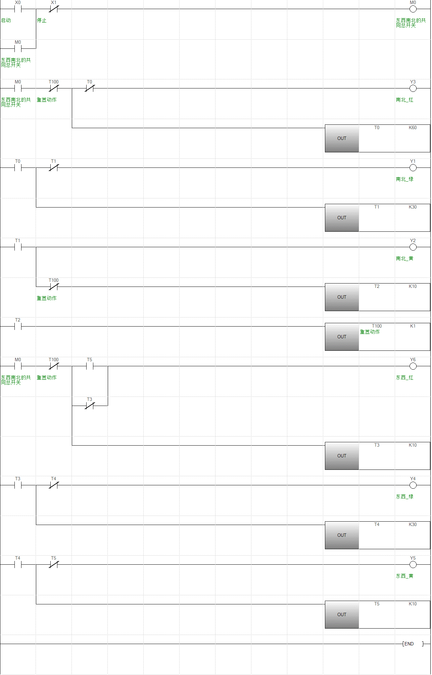

* + - 1. I/O Table

|  |  |  |  |
| --- | --- | --- | --- |
| X0 | SB1 | Y3 | HL3 |
| X1 | SB2 | Y4 | HL4 |
| Y1 | HL1 | Y5 | HL5 |
| Y2 | HL2 | Y6 | HL6 |

* + - 1. FX5U Program Design Process
  1. Flowchart Design



* 1. Module design based on LAD

There are three kinds of module in this program.

Module 1: Start-Hold-Stop module

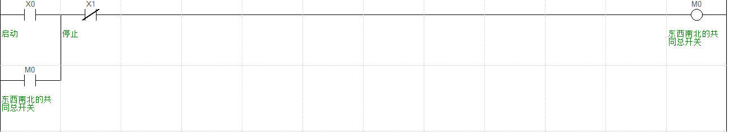

Module 2: traffic lights control module

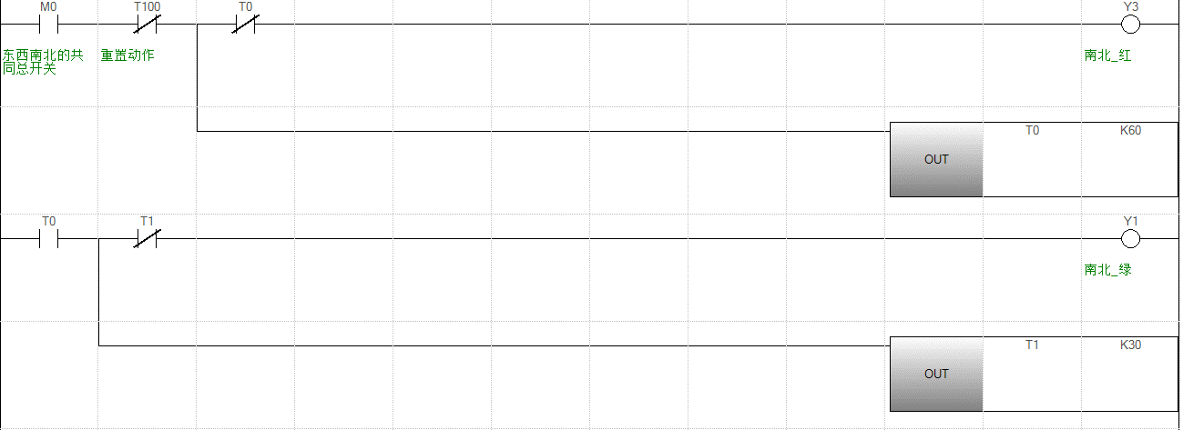

T100 use to reset the system. M0 close, the light and timer start to work. Closing the light and start next light-timer module when timer counts down and taking action.

Module 3: reset module

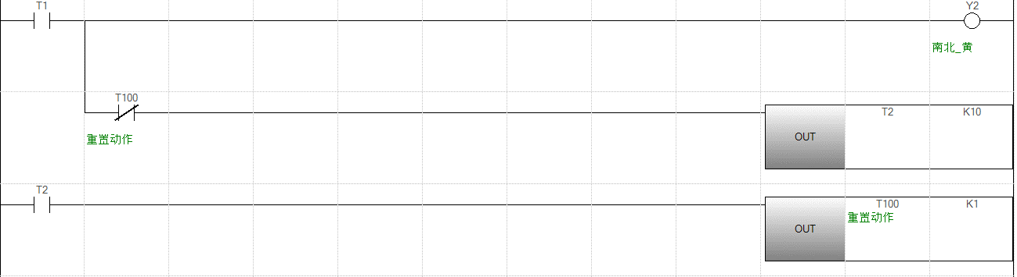

The yellow light on North-South direction has last action, so we set a pulse generation circuit here to reset the hole system except Start-Hold-Stop module. When T2 counts to 10 T100 start to counts 1. Action on T100(open) will make system power off but Start-Hold-Stop module still working. Power off make T100 return to original state(close). That completes a reset.

* 1. Instruction Table

|  |  |  |  |
| --- | --- | --- | --- |
| 机型信息: | FX5CPU FX5U |  |  |
| 步号 | 行间声明 | 指令 | I/O(软元件) |
| 0 |  | LD | X0 |
| 2 |  | OR | M0 |
| 4 |  | ANI | X1 |
| 6 |  | OUT | M0 |
| 8 |  | LD | M0 |
| 10 |  | ANI | T100 |
| 12 |  | MPS |  |
| 13 |  | ANI | T0 |
| 15 |  | OUT | Y3 |
| 17 |  | MPP |  |
| 18 |  | OUT | T0 |
|  |  |  | K60 |
| 23 |  | LD | T0 |
| 25 |  | MPS |  |
| 26 |  | ANI | T1 |
| 28 |  | OUT | Y1 |
| 30 |  | MPP |  |
| 31 |  | OUT | T1 |
|  |  |  | K30 |
| 36 |  | LD | T1 |
| 38 |  | OUT | Y2 |
| 40 |  | ANI | T100 |
| 42 |  | OUT | T2 |
|  |  |  | K10 |
| 47 |  | LD | T2 |
| 49 |  | OUT | T100 |
|  |  |  | K1 |
| 54 |  | LD | M0 |
| 56 |  | ANI | T100 |
| 58 |  | MPS |  |
| 59 |  | LD | T5 |
| 61 |  | ORI | T3 |
| 63 |  | ANB |  |
| 64 |  | OUT | Y6 |
| 66 |  | MPP |  |
| 67 |  | OUT | T3 |
|  |  |  | K10 |
| 72 |  | LD | T3 |
| 74 |  | MPS |  |
| 75 |  | ANI | T4 |
| 77 |  | OUT | Y4 |
| 79 |  | MPP |  |
| 80 |  | OUT | T4 |
|  |  |  | K30 |
| 85 |  | LD | T4 |
| 87 |  | MPS |  |
| 88 |  | ANI | T5 |
| 90 |  | OUT | Y5 |
| 92 |  | MPP |  |
| 93 |  | OUT | T5 |
|  |  |  | K10 |
| 98 |  | END |  |

* 1. Simulation and debugging

Start:

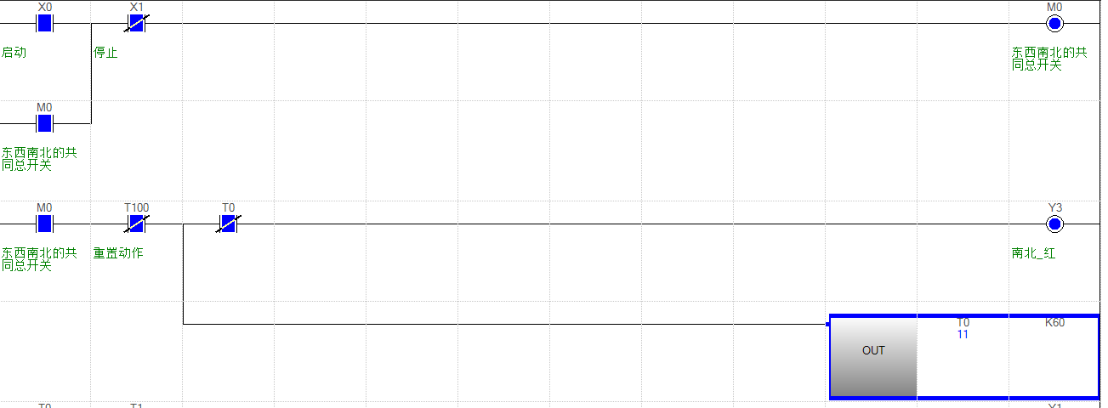

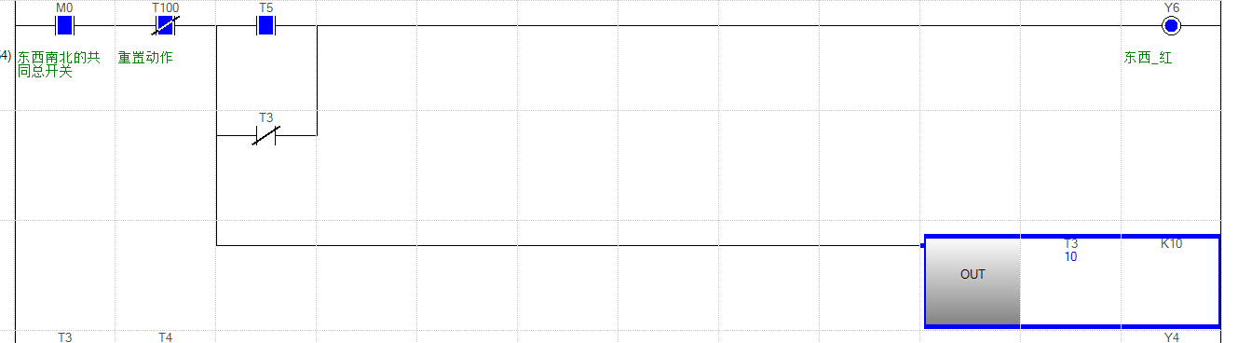

Then

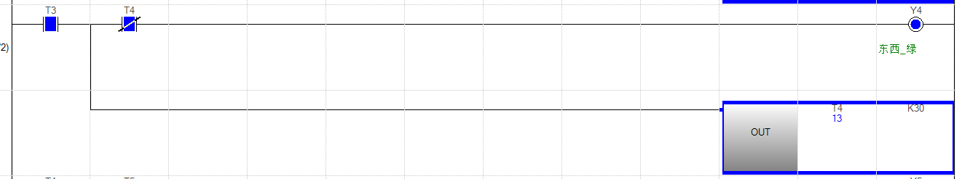

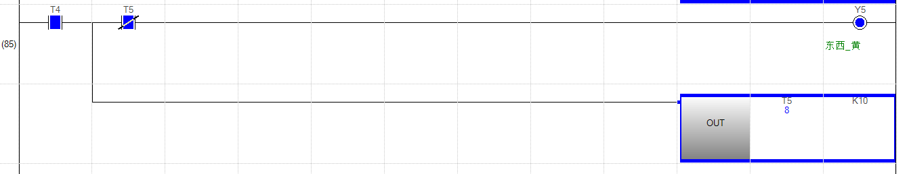

Then

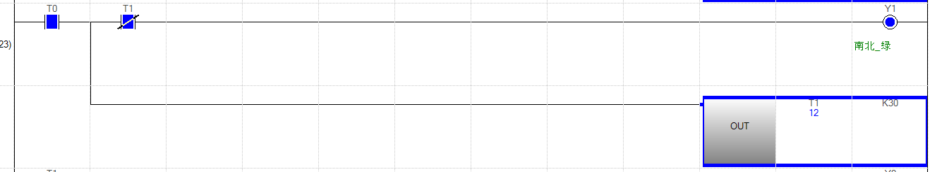

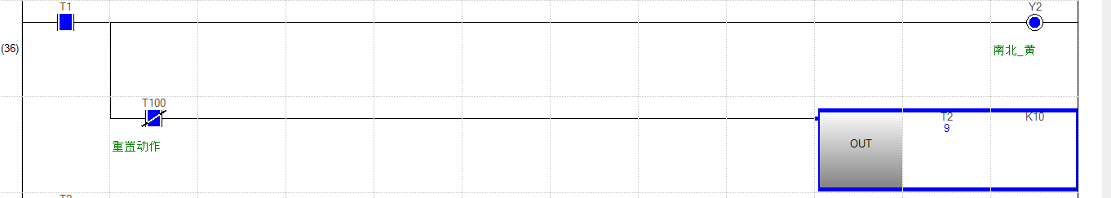

* + - 1. HMI Program Design Process

Fist of all, we need to read some information about the HMI

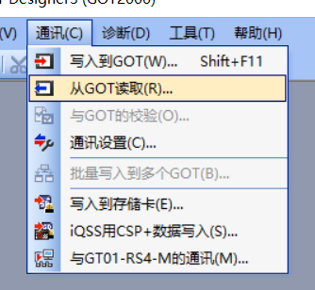

Press “yes” in the window

Press “Get GOT information” to get model of HMI

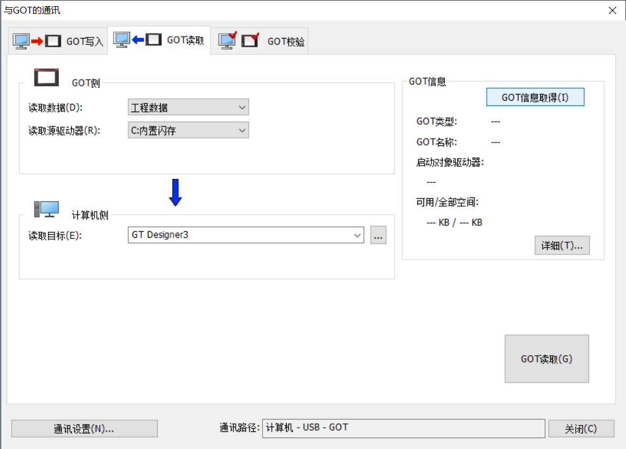

Then create a new project and writing the information of HMI and FX5U

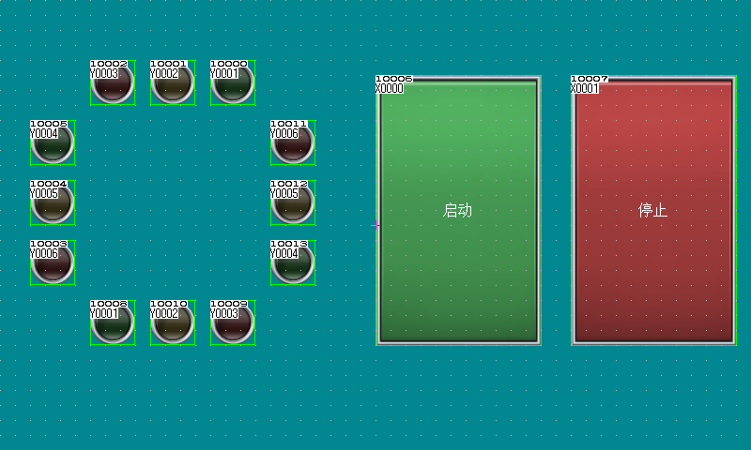

* + - 1. FX5U and HMI simulation and debugging

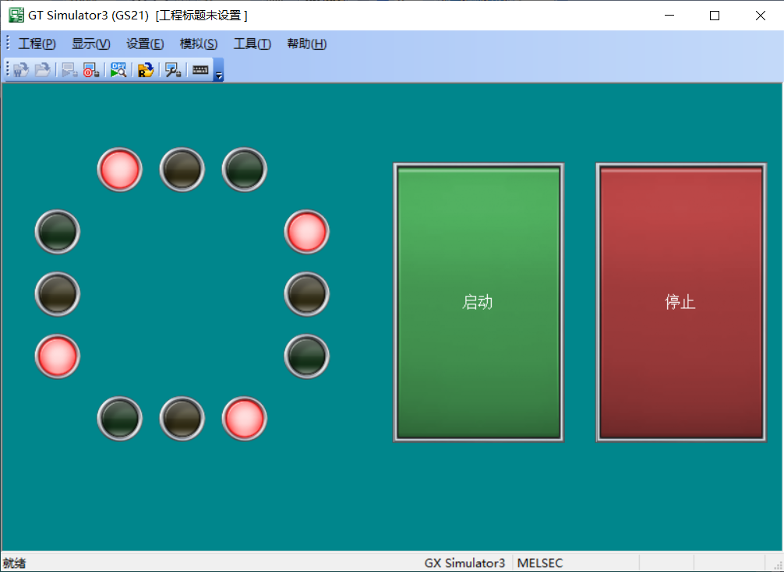

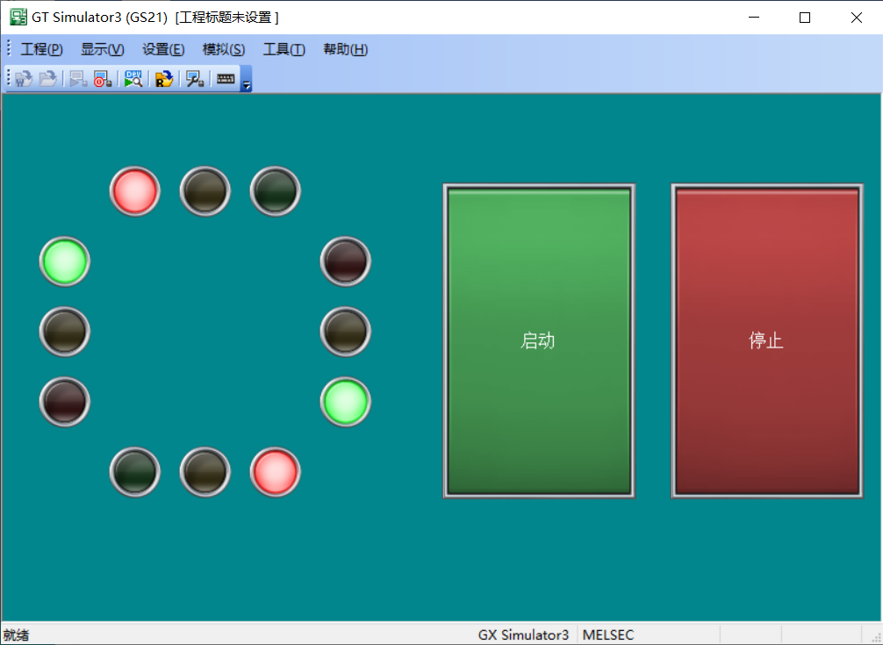

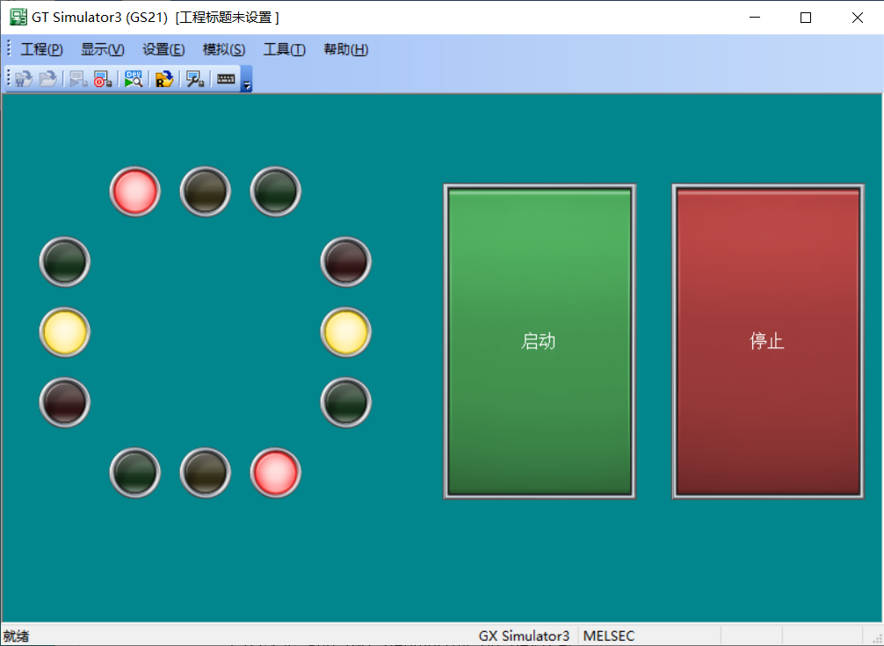

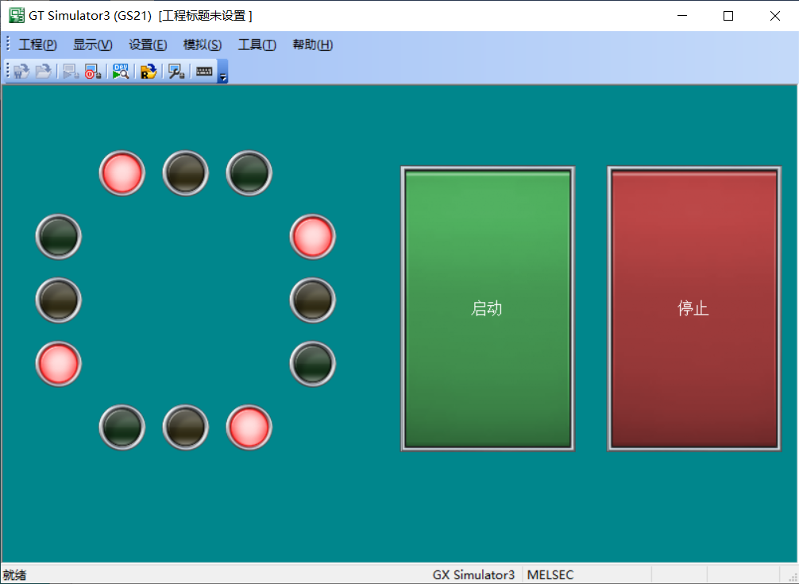

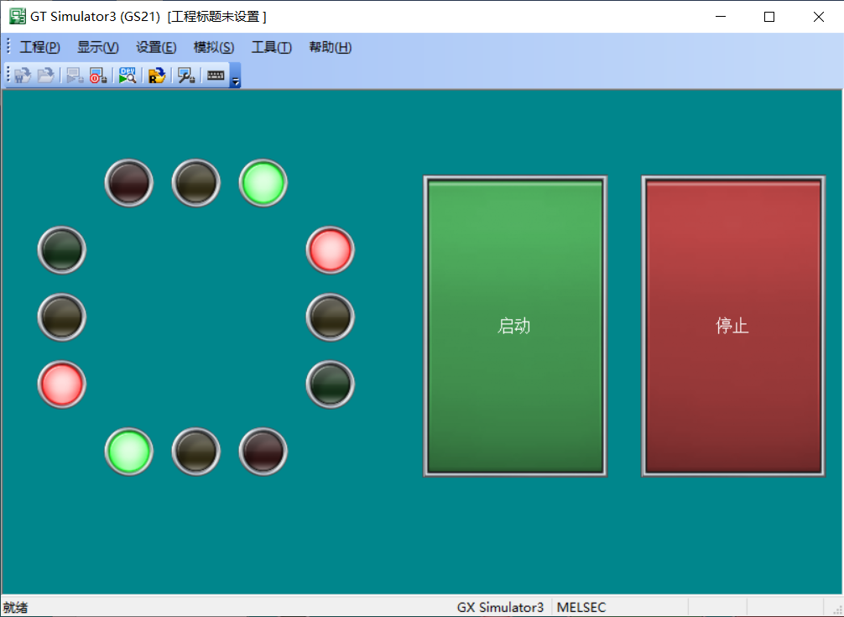

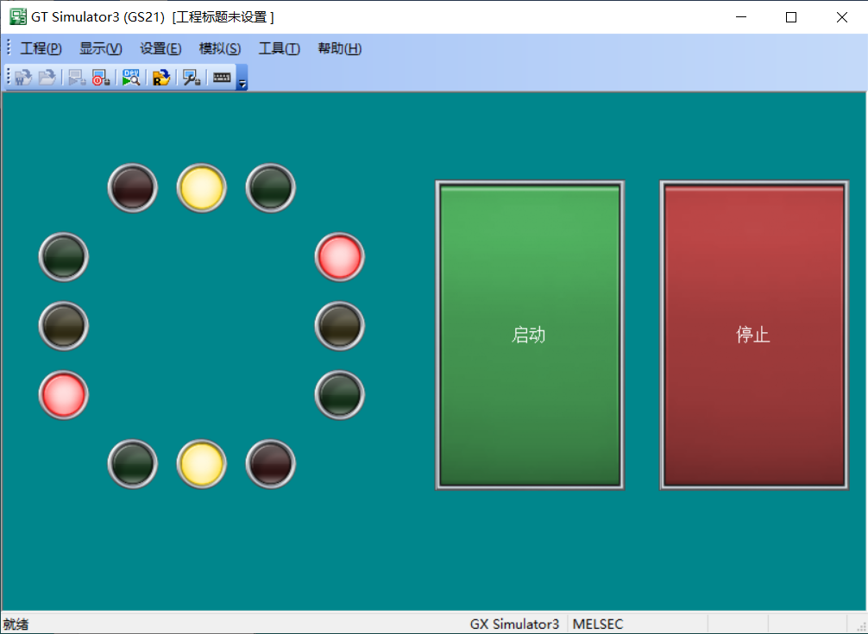

* + - 1. FX5U and HMI debugging on Device
  1. Upload program to FX5U

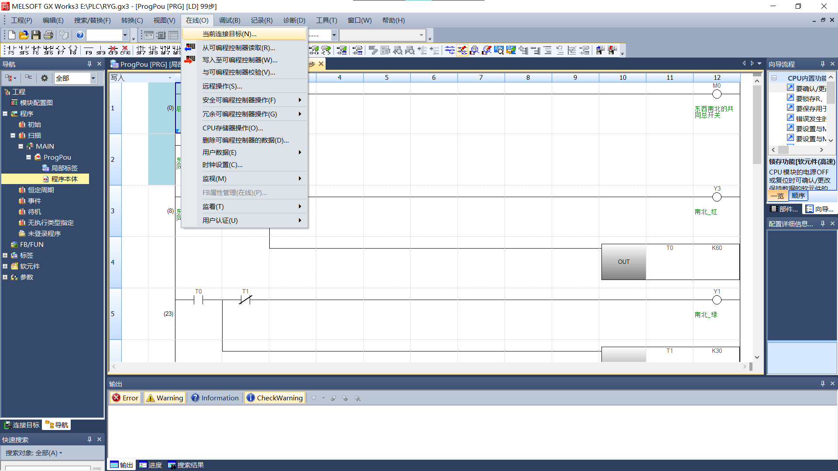Open the program and link FX5U

Select network card and press‘communications test’

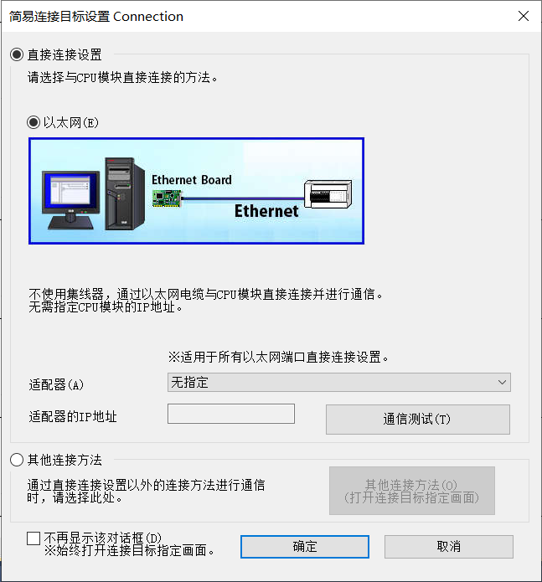

Upload to FX5U

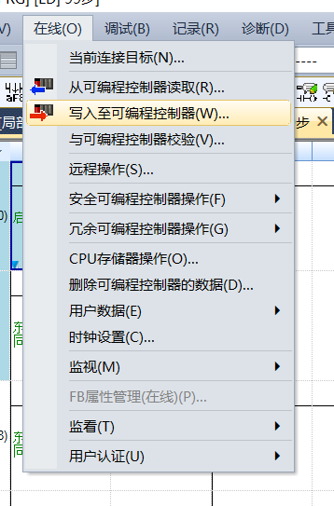

Press ‘Parameters + Programs’

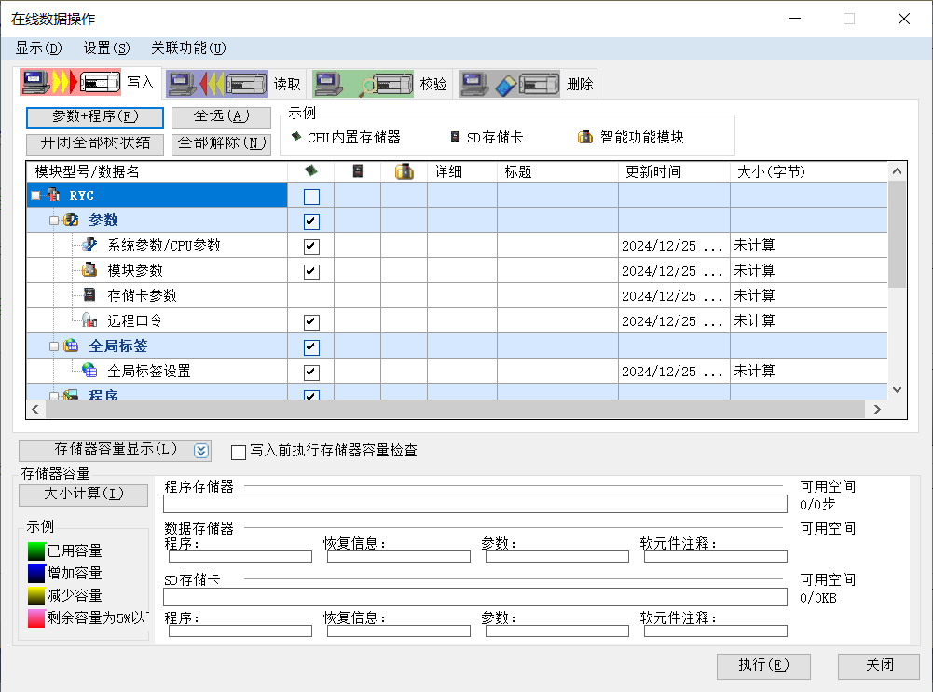

Then start to upload.

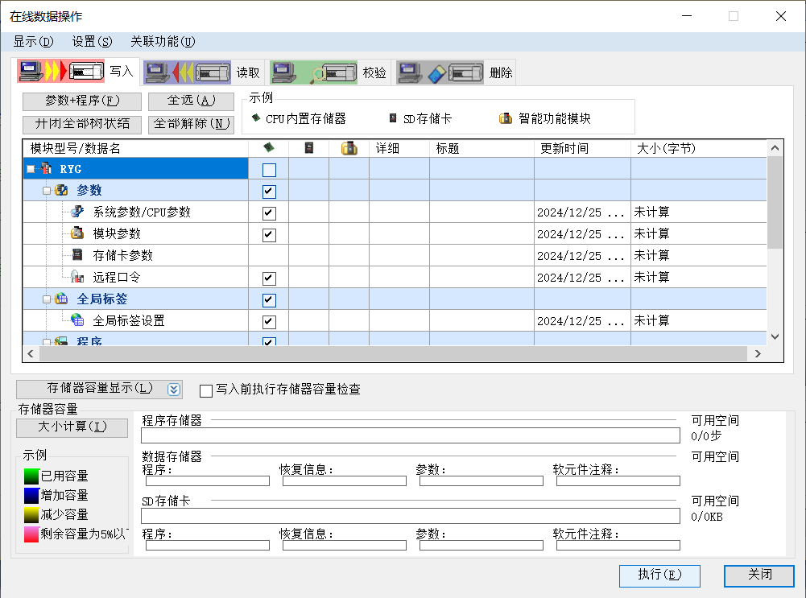

Waiting for uploading. Then take hardware reset in FX5U.

Using cable to link HMI and go run.

* 1. Upload program to HMI

Open the program and link HMI

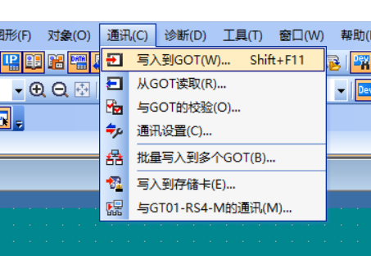

Press“yes”in the window

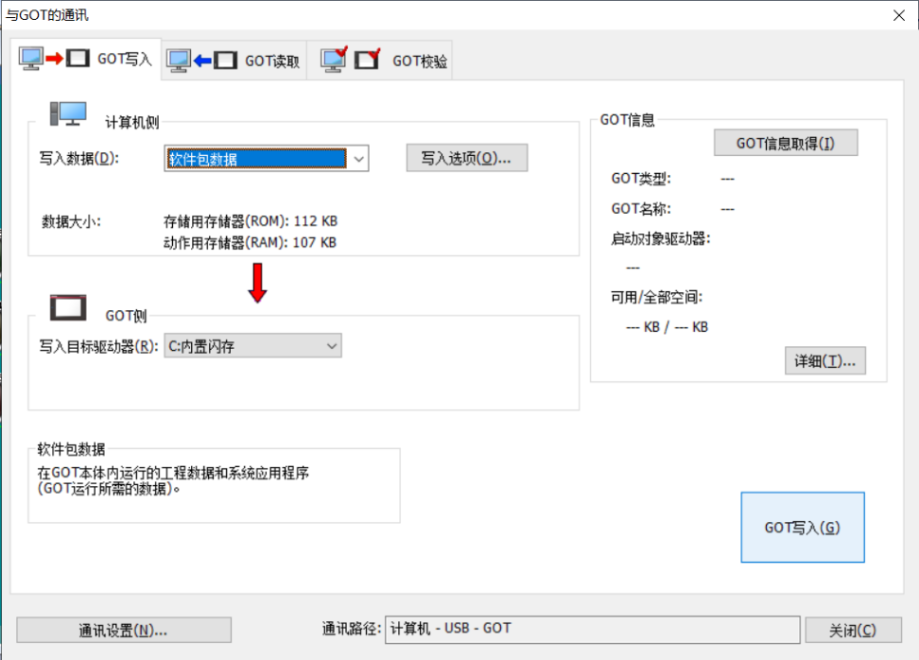

Press “GOT write”

Waiting for uploading.

* 1. 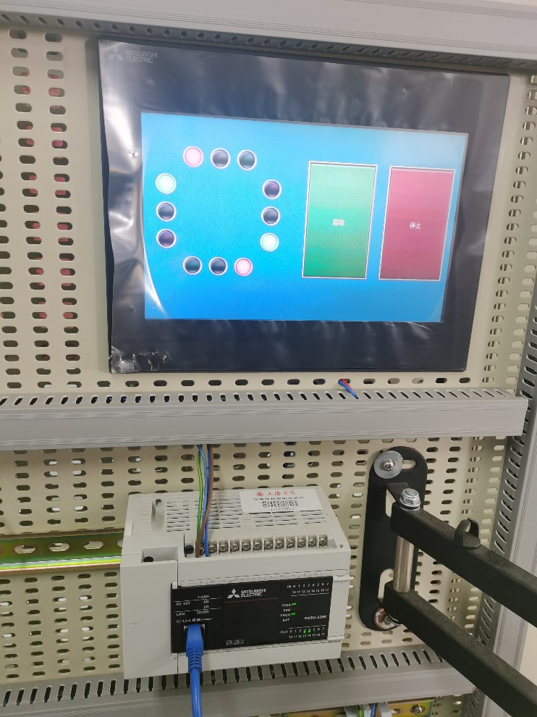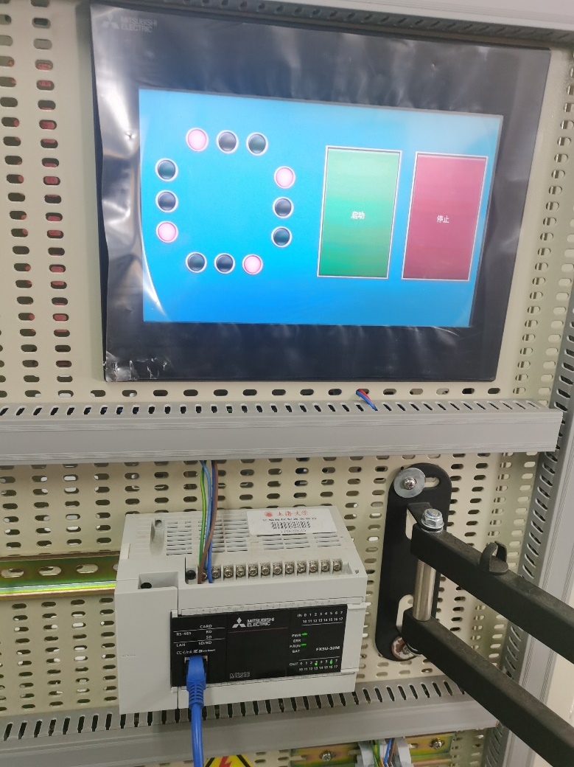Experimental result

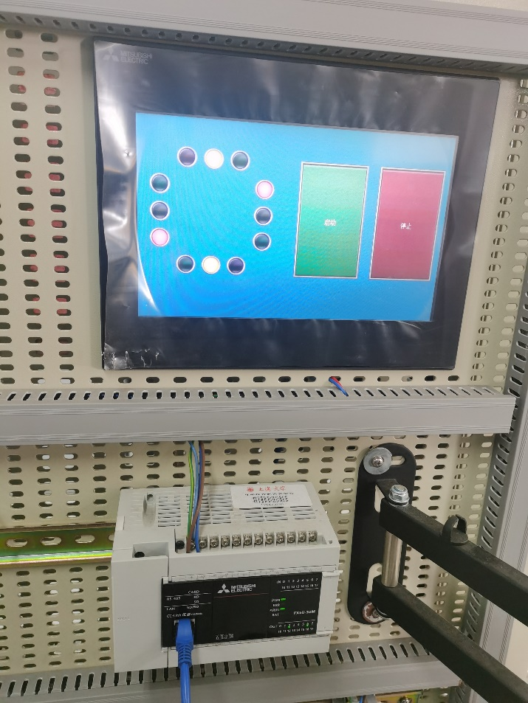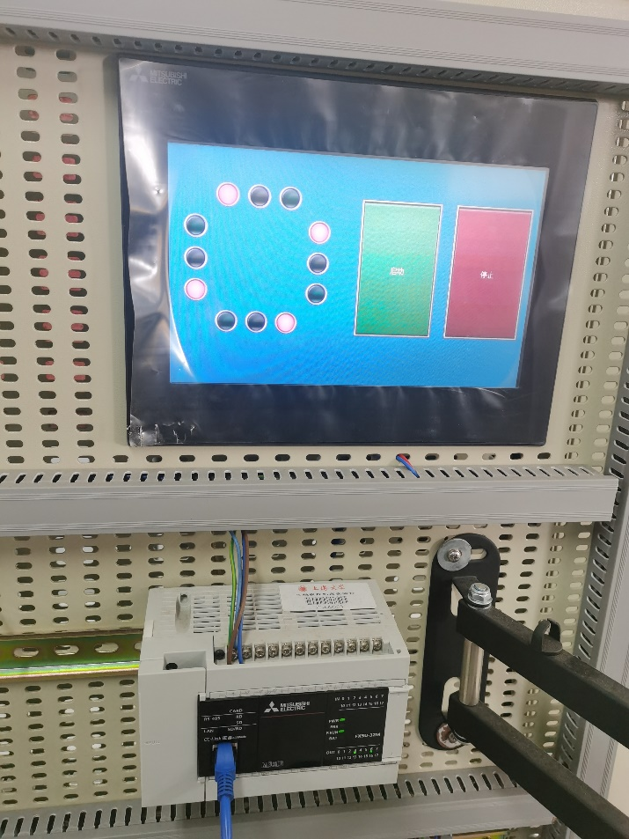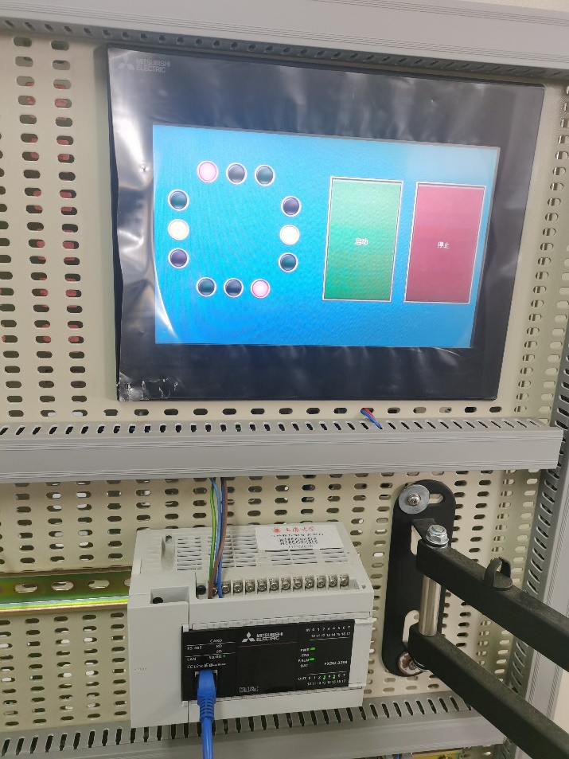

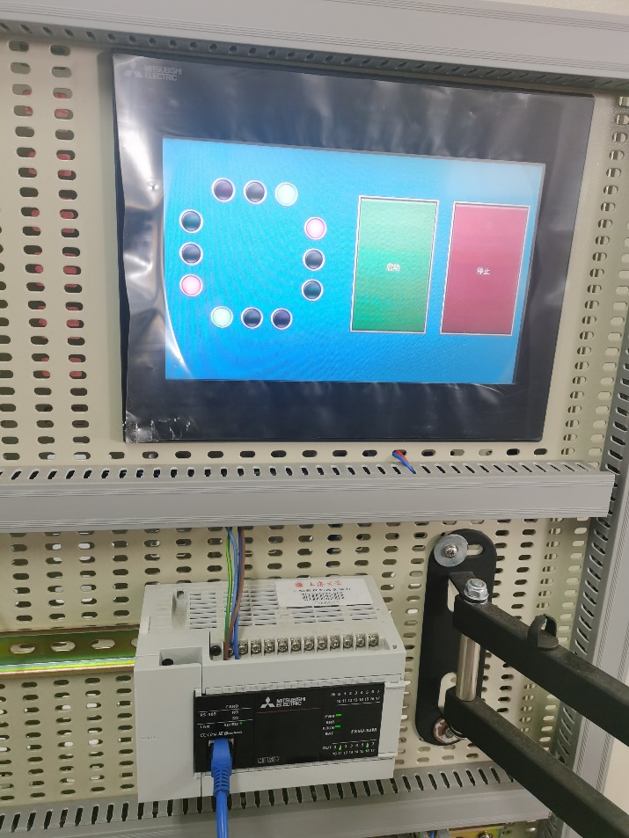

1. **Summarize Experience**

The report details a PLC experiment focused on designing a traffic light control system using FX5U PLC, a touch screen, and GX Works3 software. The objective was to control lights for four traffic directions (east-west and north-south) using synchronized outputs. The experimental setup included hardware such as the FX5U PLC, HMI touch screen, network and USB cables, alongside programming and debugging with GX Works3 and GT Works3 software. The design process involved creating modules for Start-Hold-Stop operations, traffic light sequencing, and system reset. Ladder logic (LAD) diagrams and timers like T0 and T100 were used to implement the light control sequence and manage system transitions.

Simulation and debugging were conducted both virtually and on physical devices, integrating FX5U with the HMI interface. The HMI programming required obtaining device information, setting up a project, and uploading programs to the FX5U and HMI for real-world testing. The experimental results confirmed the successful operation of the traffic light system, highlighting effective synchronization and functionality. The report concludes with reflections on the practical experience gained, emphasizing the importance of integrating hardware and software in real-world applications.